Create a vetting request

Procedure | Follow the steps below to create a vetting request.  Step Action  1 Click Open Agency next to the agency you want to create a new vetting request for. Result: The Request History screen displays. 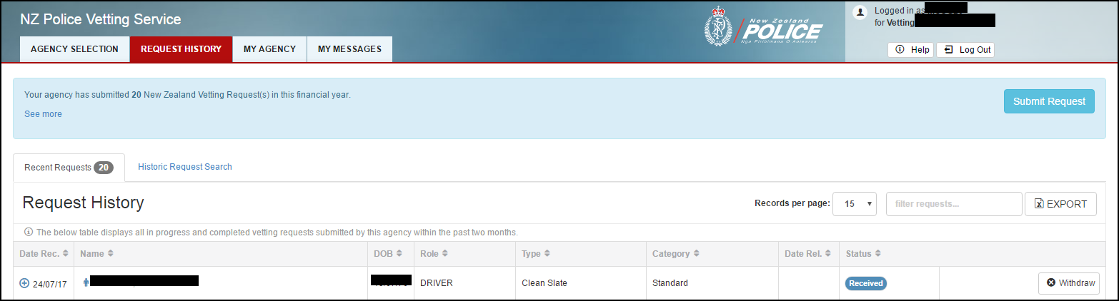  2 Click Submit Request. Result: Read the table below to see what happens and what you need to do next. IF this is … THEN… your agency’s first vetting request you will be prompted to create a new role. Action: go to Create a vetting request: Create a new role and create a new role. not your first vetting request a list of previous roles that you have used will display. Action: - If you want to use a previous role, then go to step 3. OR - If you want to create a new role, then go to Create a vetting request: Create a new role and create a new role.
Continued on next page
Create a vetting request, Continued

Procedure – continued | Step Action  3 Click the previous role that you want to use for this vetting request. Result: A summary of the role displays and asks you to confirm your answers for the selected role. Example: An example of a role summary is shown below. 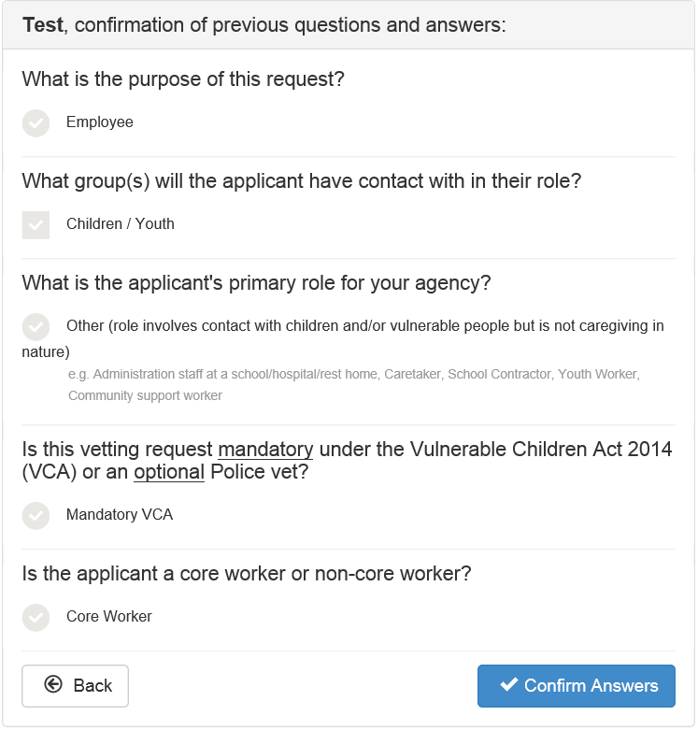
Continued on next page
Create a vetting request, Continued

Procedure – continued | Step Action  4 Read the table below to see what to do next. IF this information is… THEN… correct for the role that you are submitting a vetting request for click Confirm Answers. not correct for the role that you are submitting a vetting request for click Back and select another role that does match or create a new role.  5 Complete the appropriate fields for this vetting request. Note: The information that you need to complete will depend on the agency and the type of vetting request.  7 Carefully review everything for this vetting request. Note: - You should double check the information for this vetting request against the request and consent form (or the other approved form). - If you make a mistake in your vetting request and it gets rejected by us or withdrawn by you, then you will be charged if you do not receive a fee exemption or fee waiver.  8 Click Submit Request. Result: - Your vetting request is submitted. - You return to the Request History screen. - Your vetting request is listed on the Request History screen as Received.

Create a vetting request: Create a new role

Introduction | This topic tells you how to create a new role when you create a new vetting request.  Note: Not all of the described questions will display. The questions you see will depend on the previous answers that you gave.

Before you begin | This procedure is part of another procedure, create a vetting request.  Before you can create a new role, you should have already:  - Logged in to the Police Vetting Service secure website.  See: Log in to the Police Vetting Service secure website.  - Opened the correct agency.  See: Create a vetting request.  - Clicked Submit Request to start creating the vetting request.
Procedure | Follow the steps below to create a new role for a vetting request.  Step Action  1 Click Create New Role. Result: The following question displays. 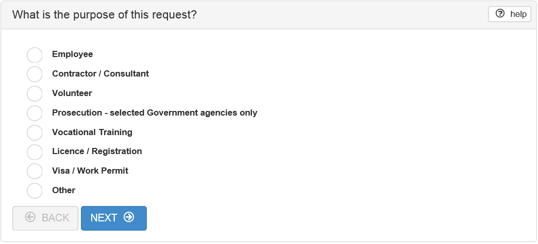 Note: - These questions ensure the correct type of vetting request is selected. Examples: Clean Slate, Exception, Vulnerable children check. - The Police Vetting Service cannot provide you with any guidance as to whether your agency is legislatively required to submit requests under the Vulnerable Children Act 2014. For more informaiton about this, see: www.childrensactionplan.org.nz.
Continued on next page
Create a vetting request: Create a new role, Continued
Procedure – continued | Step Action  2 Select the applicant’s purpose for the vetting request and click NEXT. Result: The following question displays. 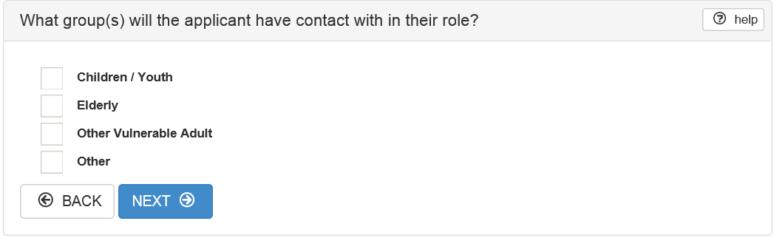  3 Select the group or groups that the applicant will have contact with in their role and click NEXT. Result: The following question, or something very similar displays. Note: The descriptions that display will depend on what you have selected in the previous questions. 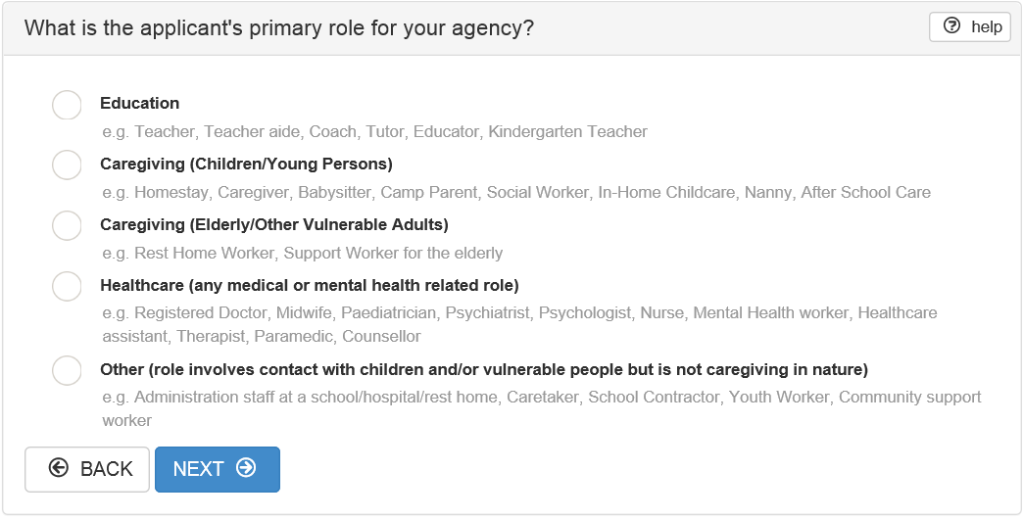  4 Select the applicant’s primary role for your agency and click NEXT. Result: The following question may display, depending on what you have selected in the previous questions. Note: If this question doesn’t display, then return to the Create a new vetting request (Step 5) procedure. 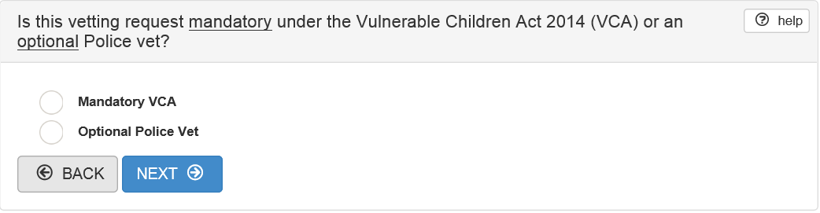
Continued on next page
Create a vetting request: Create a new role, Continued
Procedure – continued | Step Action  5 Select whether the vetting check is mandatory under the Vulnerable Children Act 2014 or optional and click NEXT. Result: - If you select optional, then the screen displays the fields that you need to complete for this vetting request. Return to Create a new vetting request (Step 5) - If you select mandatory, then the following question displays. 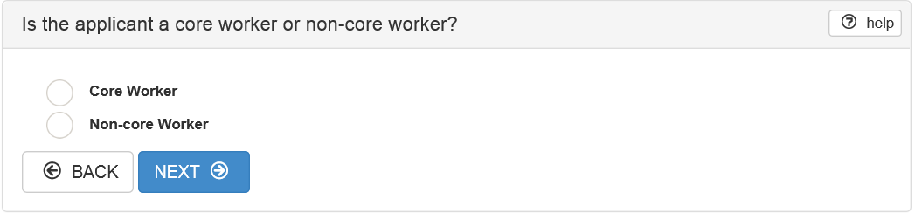  6 Select core worker or non-core worker and click NEXT. Result: The vetting request details display a series of fields relevant to what you have selected in the previous questions. Example: 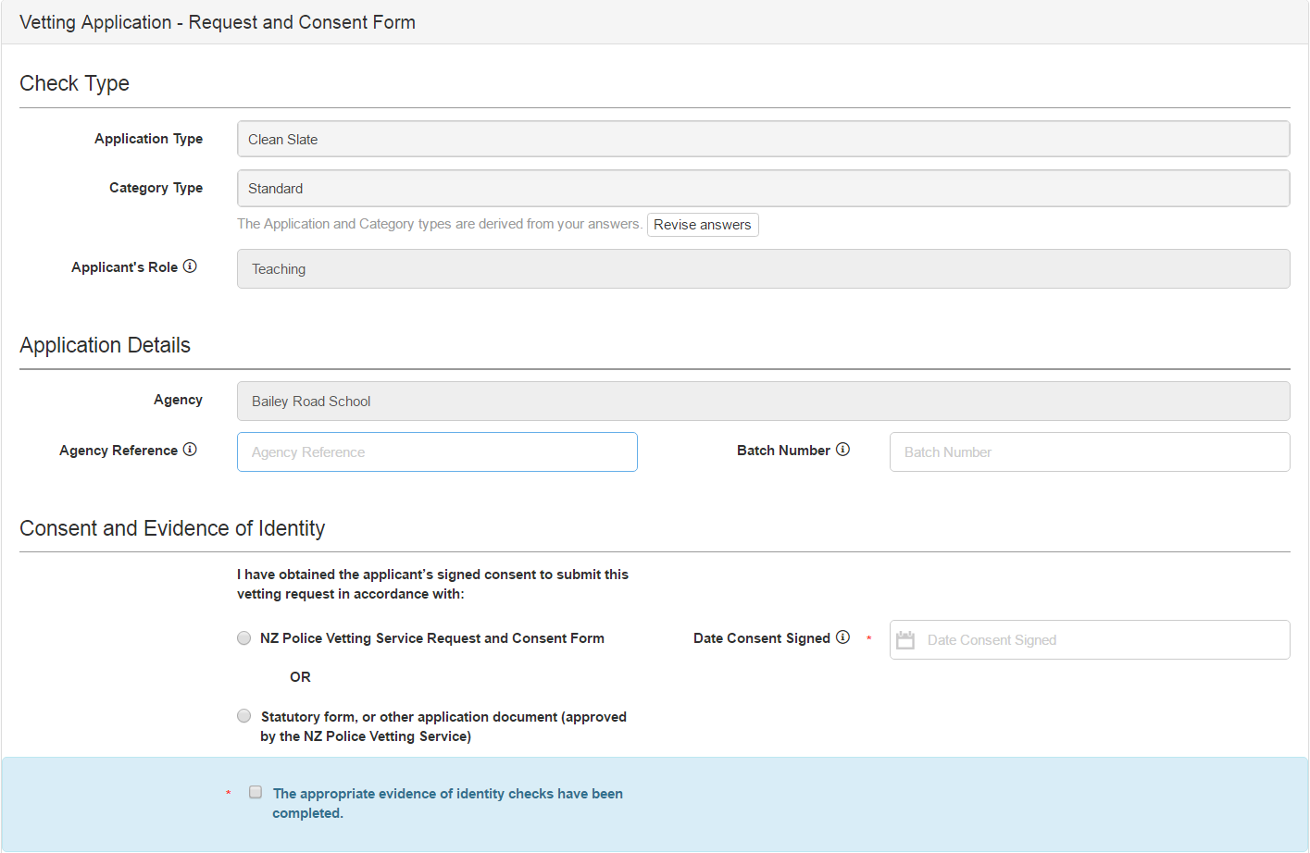  7 Complete the appropriate fields for this vetting request and click Submit Request.

NOTE: A maximum of ten unique roles can be saved for re-use in future requests.

Once ten unique roles have been created, any requests submitted with a new role will cause the oldest of the existing roles to drop off the list.

